**Assembly Fall 2017 Sec C Lab 07**

**Task 1:**

See sum_sub_routine.asm file.

1. In this file, there is a sub routine that takes as parameter the address of array and the number of elements in it.
2. The sub routine finds the sum of elements and stores the sum in memory.
3. This routine is using some registers such as bx, bp, ax, cx for the task. When the routine exits the values of these registers are not the original values.

**To Do:** Change the sub routine so that the original values of these register (those registers that are used by the routine) is unchanged after running the routine. You must not use memory for storing the registers; also you are not allowed to change the logic. The program must run fine after you have added your own code (Hint: Temporarily push the registers on the stack and pop them before returning from the routine. **Do not use pusha / popa instructions**).

**Task 2:**

Write a program that calculate the following series:

$$ans=\sum_{n=1}^{l}{r^{n}/n}$$

Where r and l are variables. If r =2 and l = 8 then final answer is 4C, but this time you have to make functions. A power function which take base and exponent and then return answer on stack, A divide function that take dividend and divisor and return answer on stack.

**Task 3:**

Write the sub-routine that reverse a number (16 bit number), it accepts a number’s address, then return reversed number on stack. You are not allow to declare or use any array

# Task 3:

Write the sub-routine to find a number in a sorted array, for this purpose use binary search algorithm. Save location of key in DX. In following code “l” is lower limit of array 0 in start and “r” is upper limit of array length -1 in start and “x” is key.

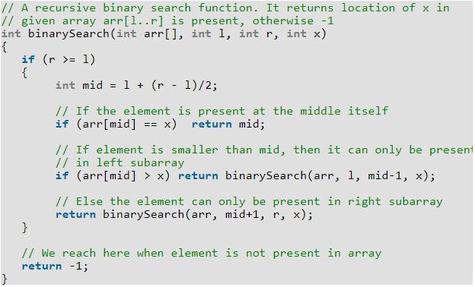

**Task 4:**

A palindrome is a word, phrase, [number](https://en.wikipedia.org/wiki/Palindromic_number), or other sequence of [characters](https://en.wikipedia.org/wiki/Character_(symbol)) which reads the same backward as forward, such as 12321 or 52325.

Write a recursive function that return a Boolean value, receive an integer array address, start and end index. It returns true, if array is palindrome otherwise false.